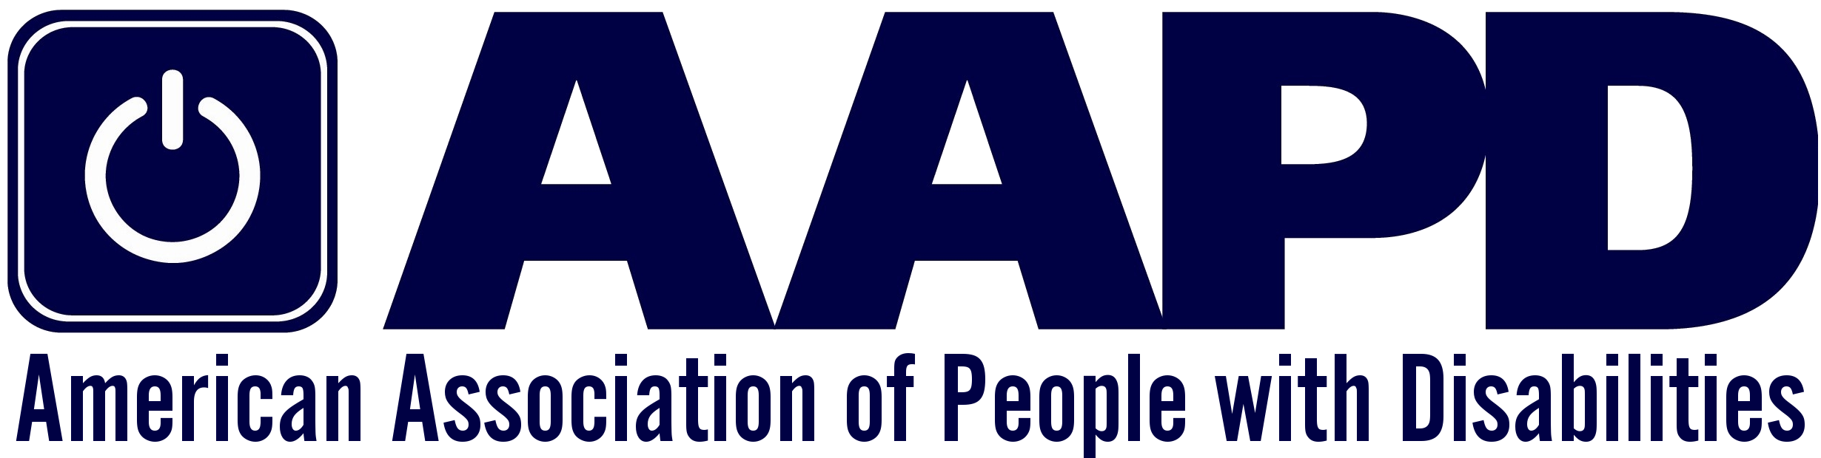

JOB ANNOUNCEMENT

CHIEF OPERATING OFFICER
Organization: AAPD
Organization website: www.aapd.com
Title: Chief Operating Officer
Position Level: Senior
Job Type: Full-time, hybrid schedule available with approval of President & CEO
Reports To: President & CEO
Location: Washington, DC
Salary: $135,000 - $150,000
Soft Closing Date: April 30, 2023

Organization Overview
The American Association of People with Disabilities (AAPD)
is a convener, connector, and catalyst for change, increasing
the political and economic power of people with disabilities.
As a national non-profit 501(c3) cross-disability rights organization,
AAPD advocates for full civil rights for more than 60 million
Americans with disabilities by promoting equal opportunity,
economic power, independent living, and political participation.
Established in 1995, for more than 25 years AAPD has collaborated
across initiatives – such as our Summer Internship Program, REV UP, and our policy advocacy, to actively uplift and center the diversity of the disability community. Learn more at www.aapd.com.

The Opportunity
AAPD is seeking an experienced senior manager for a newly created position for an individual with a disability who embodies AAPD’s mission and is invested in helping AAPD continue building the disability rights movement. The ideal candidate is an individual with a disability with deep roots in the disability community who has experience overseeing all administrative and operational functions of a non-profit organization as assigned by the President & CEO. The AAPD Chief Operating Officer (COO) is a senior leadership and management position. The person will have important internal facing responsibilities. The COO will be a critical thinking partner to the President and CEO and will help shape the vision, strategic direction, and the organization’s priority activities. The COO will also help AAPD deliver on its mission by ensuring that the programmatic work is carried out in a manner consistent with AAPD’s values and goals. This is an exciting and expansive role that includes partnership and project management (business development, framing of key approaches, high-quality client delivery, written products), organizational administration, and human capital responsibilities (HR/recruiting, mentoring, career progression). Additionally, the person will help develop and oversee program and organizational evaluations to measure results and ensure fidelity. The COO will partner closely with the President and CEO to chart AAPD’s future growth and strategic responses to a dynamic and ever-growing disability community.

Roles and Responsibilities
AAPD’s COO is responsible for the following:

- Partner with the President and CEO in strategic internal (e.g. human resources, administrative and organizational) and external activities (e.g. conferences, partnerships and coalitions)
- Ensure consistency among the vision, mission, values, strategic plan, and day-to-day operations of the organization
- Develop thought leadership around specific topics/emerging in disability related practice areas, including sharing knowledge and disseminating information to stakeholders
- Plan and oversee expansion, reach and impact of AAPD on a local and statewide levels to the disability community, including convening stakeholders to advocate for justice for people with disabilities at the state and Federal levels
- Support the board of directors and staff to broaden the financial support for AAPD, growing the budget and programs over time, and helping the organization to transition from short-term funding commitments to long-term fiscal strength
- Oversee AAPD’s program goals and objectives and evaluate progress, effectiveness; provide support to team members to achieve all project deliverables
- Manage increasing segments of information technology, human resources (recruiting, reviews, staff deployment/workload balancing, career progression) with related internal communications
- Assist with organizational and financial activities, including identifying best practices for internal systems with an eye toward future needs and budget realities
- Lead and manage teams to create policy and program deliverables
- Mentor and coach serving as a visible, approachable sounding board and resource
- Demonstrate openness and creativity in approaching problems and opportunities for AAPD and the disability community.

Qualifications
Applicants should possess the following:

- Lived experience as a person with a disability
- Knowledge of disability rights, disability justice, and disability policy (historical and current)
- Knowledge of and commitment to racial equity work and how they intersect with disability
- 7-10 years of professional experience in operations and management
- Bachelor’s Degree or equivalent required; Master’s degree preferred
- A strategic thinker who understands how operations and finances support the broader mission of the organization
- Depth of experience in managing teams, supporting cross-functional collaboration, developing staff, and setting clear goals
- Experience in policy/advocacy a plus
- Proven ability to support organizational growth
- Experience in nonprofit financial management
- Experience overseeing and ensuring accuracy of payroll, vendor payments, employee benefits, business insurance. Ensure compliance with all labor law and employment practices
- Experience in revenue development strategies, including earned revenue and/or fundraising strategies
- Strong communication skills
- Ability to help establish and track progress towards organization-wide goals
- Actively participate in the development of funding proposals and new initiatives
- Engage with the Board of Directors, primary funders, and other key external stakeholders around organizational impact and plans for the future
- Eagerness to work as part of a team, both as a leader and in a supporting capacity, to expand the impact and visibility of AAPD
- Experience leading and supporting large coalitions of advocates
- Strong analytical, organizational, and prioritization skills
- Track record of success in roles requiring execution of multiple tasks while responding to multiple project priorities
- Experience handling sensitive data and other confidential information, and demonstrated discretion and strong judgment in such situations
- High level of initiative and desire to meet specific goals
- Demonstrated empathetic disposition and positive attitude
How to apply: Applications will be accepted until the position is filled. Applications will be reviewed as they are received. Serious candidates should submit applications on or before April 30, 2023. Applications should contain a resume and thoughtful cover letter, outlining how your skills and experience meet the qualifications described above.
Email application to Christine Griffin, cmgexecsearch@gmail.com with “AAPD COO Search” in the subject line. Please include how you heard about the search.
Only a select number of highly qualified individuals will be invited to participate in a formal interview process. This is a confidential process and will be handled accordingly throughout all phases of the recruitment and selection process.
Accessibility accommodations for any portion of the application or interview process are available by emailing your request to Christine Griffin at cmgexecsearch@gmail.com

AAPD is an equal opportunity employer and seeks qualified applicants without regard to race, color, sex, religion, national origin, veteran, age, disability, marital status, gender identity or sexual orientation.

