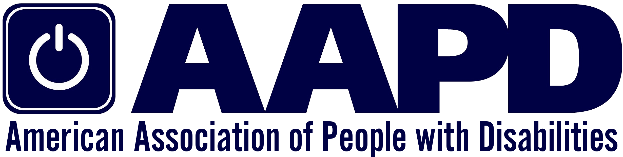

JOB ANNOUNCEMENT

VICE PRESIDENT OF POLICY
Organization: AAPD
Organization website: www.aapd.com
Title: VP Of Policy
Position Level: Senior
Job Type: Full-time, hybrid schedule available with approval of President & CEO
Reports To: President & CEO
Location: Washington, DC
Salary: $135,000 - $150,000
Soft Closing Date: July 28, 2023

Organization Overview
The American Association of People with Disabilities (AAPD)
is a convener, connector, and catalyst for change, increasing
the political and economic power of people with disabilities.
As a national non-profit 501(c3) cross-disability civil rights organization, AAPD advocates for full civil rights for more than 60 million Americans with disabilities by promoting equal opportunity, economic power, independent living, and political participation.

Established in 1995, for more than 25 years AAPD has collaborated
across initiatives – such as our Summer Internship Program, REV UP, and our policy advocacy, to actively uplift and center the diversity of the disability community. Learn more at www.aapd.com.

The Opportunity
The AAPD Vice President (VP) of Policy plays a key role in advancing policy change to ensure that people with disabilities have the right to equal opportunity and political participation to be economically self-sufficient. The VP of Policy is also responsible for helping to develop and implement AAPD’s policy research agenda and communicating with policymakers, stakeholders, and the public about AAPD’s public policy work.
The VP of Policy oversees and directs the AAPD policy staff to ensure that the team understands all aspects of the policy process and identifies opportunities for legislative and administrative policy change; and coordinates with government affairs staff to implement an agenda that advances key strategic goals, including expanding the availability of home and community-based services, addressing discrimination in healthcare services, income support programs, access to accessible and affordable housing, transportation, affordable healthcare, universally designed technology, equal employment opportunities, inclusive education, and civic engagement. The VP of Policy works closely with the Policy Committee of AAPD’s Board and the Senior Policy Associate. The VP of Policy is responsible for working to advance AAPD’s policy priorities to policymakers, coordinating efforts with other programmatic and advocacy priorities within AAPD, and working with the broader disability and civil rights community to advance equal opportunity, economic power, independent living, and political participation of disabled people.

AAPD is seeking an experienced senior manager for the VP of Policy role who will partner closely with the President and CEO to chart AAPD’s future growth and strategic responses to a dynamic and ever-growing disability community. AAPD offers in-person, hybrid, and remote employment options.

Roles and Responsibilities
AAPD’s VP of Policy is responsible for the following:

- Providing leadership, along with other staff and partner organizations, in the development and implementation of long-term policy priorities and strategy while providing day-to-day management and supervision of policy staff.
- Cultivating and building powerful relationships with key policymakers and influencers in service of AAPD’s priorities. These policymakers and influencers include but are not limited to Members of Congress, Administration Officials, regulators, and state and municipal leaders.
- Collaborating with AAPD’s programs and communications staff to integrate AAPD’s policy priorities across all areas of our work.
- Participating in coalition-building strategies at the national level and maintaining key relationships with partner organizations.
- Providing reliable analysis and strategic guidance on developments related to AAPD’s policy priorities and other timely issues.
- Tracking federal and state policy and political developments and directing AAPD’s strategic response to those developments as appropriate, including rapid-response communications or analyses
- Determining appropriate papers, analytic work, political strategies, and communications
- Developing and disseminating policy analysis and advocacy materials
- Drafting statements, talking points, letters, comments, action alerts and responses on behalf of AAPD
- Ensuring the involvement of grassroots leaders and partner organizations in promoting agreed upon priorities and helping to organize opportunities to bring grassroots partners in contact with their member of Congress, the Administration and other policymakers.
- Conducting and/or commissioning research as necessary; and serving as project manager for policy research projects.
- Initiating, planning, and executing events such as convenings, symposia, and roundtables to encourage dialogue and ultimately better policies, programs, and systems for disabled people.
- Represent AAPD in diverse settings, including meetings with members of Congress and their staff; the White House and executive agencies; media outreach and appearances; conferences; and panel discussions.
- Responding to policy-related inquiries

Qualifications
Applicants should possess the following:
- 5-10 years of experience in government, policy advocacy, civil rights, or other relevant fields
- Deep familiarity with disability policy, including with respect to long-term services and supports, income support programs, health insurance coverage and other areas of priority.
- Deep understanding and experience with public systems and policy
- Demonstrated competence across areas of disability public policy.
- Demonstrated critical analysis skills with a capacity to learn quickly.
- Strong interpersonal, communication, and management skills, including comfortably interacting with internal and external stakeholders.
- Eagerness to work as part of a team, both as a leader and in a supporting capacity, to expand the impact and visibility of AAPD.
- Demonstrated ability to highlight complex problems, develop and evaluate options, and implement solutions.
- Proven track record of success leading high-impact and innovative policy advocacy campaigns.
- Commitment to AAPD’s mission and experience in the disability advocacy community
- Commitment to political and economic change through building the capacity and power of people with disabilities and to participate directly in changing public policies.

AAPD is particularly interested in applicants who have:
- Lived Experience as a person with a disability.
- Familiarity with applicable research literature relating to disability policy and programs and the ability to quickly synthesize research and deploy it to support policy advocacy work.
- Demonstrated experience as a team leader and/or supervisor.
- Strong desire to delegate and to mentor other policy associates.
- Demonstrated commitment to advancing social, political, economic, gender, and racial justice progress for the disability community.
- Prior experience with regulatory advocacy with respect to health care, transportation, telecommunications, voting and other areas of policy importance to people with disabilities.
- Prior experience with pursuing legislative advocacy relating to appropriations.
- Prior experience with supporting state-specific advocacy campaigns
- Familiarity software and other tools to track legislation and regulation.

HOW TO APPLY: Applications will be accepted until the position is filled. Applications will be reviewed as they are received. Serious candidates should submit applications on or before July 30, 2023. Applications should contain a resume and thoughtful cover letter, outlining how your skills and experience meet the qualifications described above.
Email application to Christine Griffin, cmgexecsearch@gmail.com with “AAPD VP of Policy Search” in the subject line. Please include how you heard about the search.
Only a select number of highly qualified individuals will be invited to participate in a formal interview process. This is a confidential process and will be handled accordingly throughout all phases of the recruitment and selection process.
Accessibility accommodations for any portion of the application or interview process are available by emailing your request to Christine Griffin at cmgexecsearch@gmail.com

AAPD is an equal opportunity employer and seeks qualified applicants without regard to race, color, sex, religion, national origin, veteran, age, disability, marital status, gender identity or sexual orientation.

