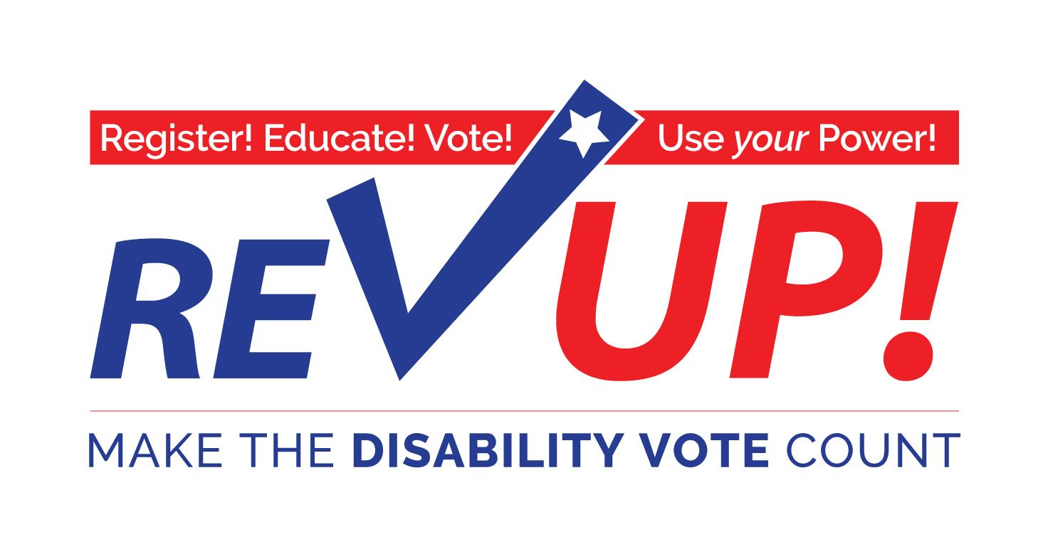
“Vote as if your life depends on it—because it does!”

-Justin Dart, Jr., father of the ADA, Texan, patriot

The November 6th election will be one of the most important elections you can vote in.

The disability community—people with disabilities, family members, attendants, providers, professionals, advocates and supporters—has a major stake in the outcome of this election.

The Disability Vote! can make a difference on issues such as:
- Implementation and enforcement of the “most integrated setting” requirements in the Americans with Disabilities Act (ADA)
- Adequate funding and coverage for Medicaid acute and long term services
- Adequate funding for quality public and higher education
- Waiting lists for home and community services
- Quality Medicaid managed care with strict accountability measures
- Consolidation and closure of public institutions
- Integrated employment at no less than minimum wage
- Accessible, affordable, and integrated housing

I pledge to VOTE on November 6th!

Name: ______________________________________________________________________
Address: ____________________________________________________________________
City: ______________________________________ State: ________ Zip: ________________
Email: ___________________________________________ Phone: _____________________
More Resources at:
www.aapd.com/REVUP

