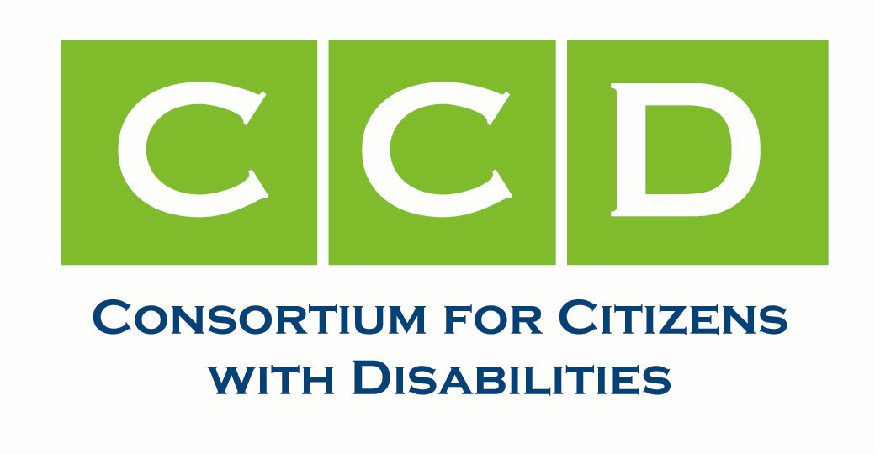

H.R. 620, the ADA Education and Reform Act Tool Kit

Congress is about to vote on a bill that would strip away the civil rights of people with disabilities. H.R. 620, also known as the “ADA Notification” bill, is scheduled to be voted on at 9 am Thursday Feb. 15. H.R. 620 would weaken the Americans with Disabilities Act (ADA) and make it harder for people with disabilities to participate in the mainstream of society.

This bill would remove any consequence for businesses with architectural barriers that violate the ADA unless and until a person with a disability provides them with a legal notice detailing how the business has violated the law. After that, the person with a disability would have to wait for six months or more for the business to fix the problem. Further, businesses would no longer have to provide access but only to make “progress.”

We need to #SaveADA and defeat this bill. You can read more about the ADA Notification bill and its harmful impact on people with disabilities here: http://c-c-d.org/rubriques.php?rubpage=43.

Now is the time to act!
We cannot and will not go backwards!
We will #SaveADA!

A House Rules Committee hearing has been scheduled for Tuesday, February 13 at 5:00 p.m. A vote on the House floor is scheduled for Thursday, February 15 at 9:00 a.m. We need advocates to take action TODAY to #SaveADA! Don’t let Congress rip the heart out of this section of the ADA!

Tell your member of Congress to vote no on HR 620 and any amendments that claim to "fix" this bill. The only way to save the civil rights of people with disabilities is to eliminate "notice and cure!"

National Disability Call-In Day (Monday, Feb. 12)
Schedule time to call your Representative TODAY! If you can call every day between now and the vote on Thursday, please do!
You can call the Capitol switchboard at 202-224-3121 to be connected to your Representative. You can use our script to talk to the staffer you are connected with:
Hello, my name is [your name] and I live in Rep. [name] district. My address is [your address].

I am calling to urge Rep. [name] to vote no on H.R. 620.

As a person with a disability/a family member of a PWD/friend of a PWD, I rely on the ADA to ensure that I/my family member/my friend can do the same things that everyone else does--including visit [something you like to do in the community, like go to the movie theater or local restaurants]. H.R. 620 would reduce the civil rights of people with disabilities.

If Rep [name] wants to help business owners and prevent frivolous lawsuits, there are better ways to do it that won’t hurt people with disabilities.

Please tell Rep. [name] that this constituent wants him to vote no on H.R. 620.

INSIDER NOTE: If the staffer asks you what those other ways are, say that you urge them to contact the CCD Rights Task Force and to see this letter: http://c-c-d.org/fichiers/UPDATED-CCD-and-Allies-Letter-of-Opposition-for-The-ADA-Education-and-Reform-Act-of-2017-H.R.620-Sept-7-2017.pdf.

Also, you can just call and say where you live and that you want Rep [name] to vote no on H.R. 620 and any amendments that claim to “fix” it. The only way to save the civil rights of people with disabilities is to eliminate notice and cure!

The vast majority of staffers won’t ask you any more questions and if they do, you don’t have to answer.

The Autistic Self Advocacy Network (ASAN) also has an excellent factsheet about calling your elected officials here:. ASAN has more resources here: http://autisticadvocacy.org/policy/toolkits/civic/.

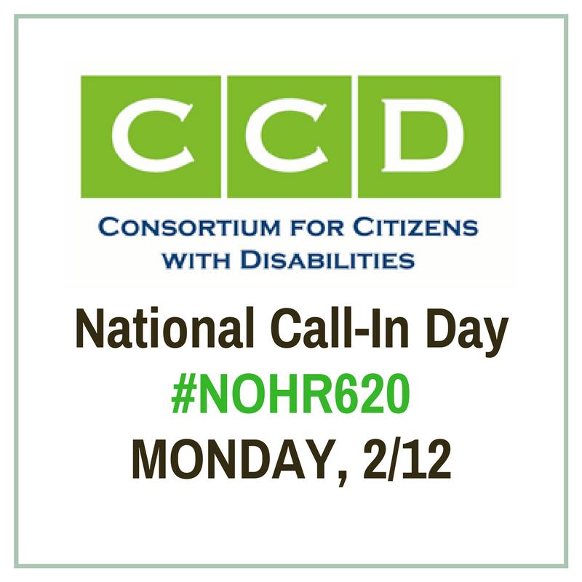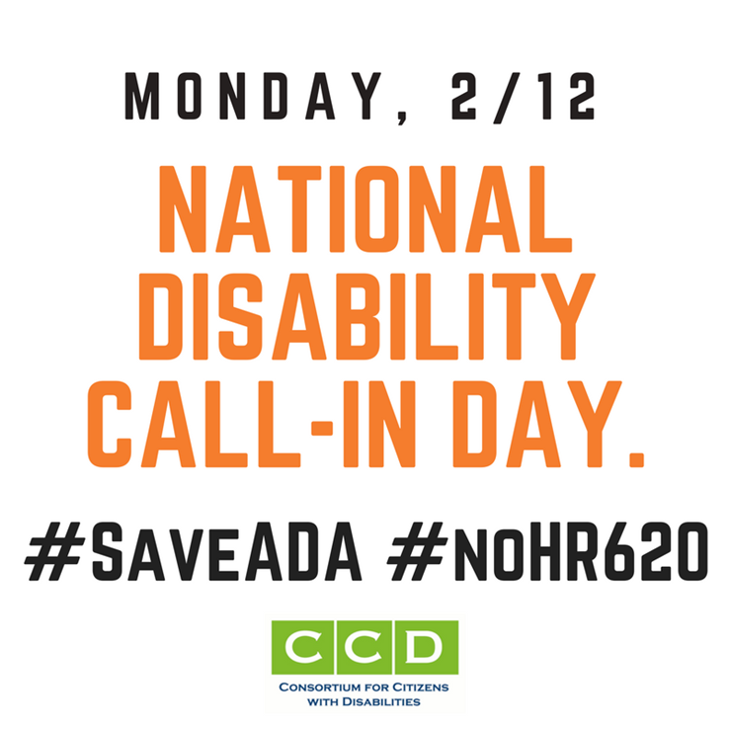

Engage on the Day of Social Action (Tuesday, Feb. 13)

On Tuesday, while the Rules Committee hearing is happening, we’ll be tweeting about how H.R. 620 will impact people with disabilities. Please join us!

Tell your story!

Like everyone else, people with disabilities visit stores, hotels, doctors' offices, laundromats, restaurants, and other places of public accommodation. They are part of everyday life. Many people have a story about not being able to access a store, restaurant, hotel, or other public space because it was not accessible. Your Representative needs to hear those stories! You can tweet at them or post to their Facebook page! You can also comment on their Facebook posts with your story!

Tweet!

We have a set of sample tweets for you to use! You can tag your representative specifically by including their username at the end of the tweet!
There is no reason, after 27 years, for a business not to comply with the #ADA –We will not wait even longer for enforcement of our civil rights! http://bit.ly/2y0VFDk Tell Congress #NoHR620 #SaveADA #27YearsTooLong

H.R. 620 undermines the very purpose of the #ADA and harms people w disabilities. #NoHR620 #SaveADA http://bit.ly/2hSS7zd @[Rep. Name] should vote #NoHR620

Letter: The Disability Community stands united in opposition to H.R. 620… #NoHR620 #SaveADA http://bit.ly/2hSS7zd @[Rep. Name] should vote #NoHR620

Fact Sheet: Myths and Truths about the #ADA Education and Reform Act of 2017: http://bit.ly/2hSS7zd Tell Congress #NoHR620 #SaveADA
The ill-informed #HR620 requires people w disabilities to jump through many
hoops before they can protect their rights: http://bit.ly/2hSS7zd Tell Congress #NoHR620 #SaveADA

The “ADA Education and Reform Act” will do nothing to stop frivolous lawsuits.
http://bit.ly/2hSS7zd Tell Congress #NoHR620 #SaveADA

There are ways to address the problem of unscrupulous attorneys w/out
burdening the rights of people w disabilities. http://bit.ly/2hSS7zd Tell Congress #NoHR620 #SaveADA

Listen to Sen. Duckworth: H.R. 620 makes Americans with disabilities second-class citizens again! http://wapo.st/2GQKUHH Tell Congress #SaveADA and vote #NoHR620

236 members of @ccd4pwd & Allies Oppose #ADA Education and Reform Act of 2017: http://bit.ly/2y0VFDk #SaveADA Tell Congress #NoHR620

#ADA has been around for 27 years - Why should a person have to wait even longer for enforcement of their civil rights? http://bit.ly/2y0VFDk Tell Congress #NoHR620 #SaveADA #27YearsTooLong

H.R. 620 treats civil rights for #PWD differently than the civil rights of other people. THIS IS WRONG. #DontRollBackOurRights http://bit.ly/2y0VFDk Tell Congress #NoHR620 #SaveADA

You can also follow and amplify the messages of our partners!

PARTNERS | HASHTAGS
@BazelonCenter  @PVA1946  @UnitedSpinal  @ACLU  @NCIL  @DREDF | #NoHR620  #SaveADA  #CripTheVote  #DontRollbackOurRights  #27YearsTooLong

