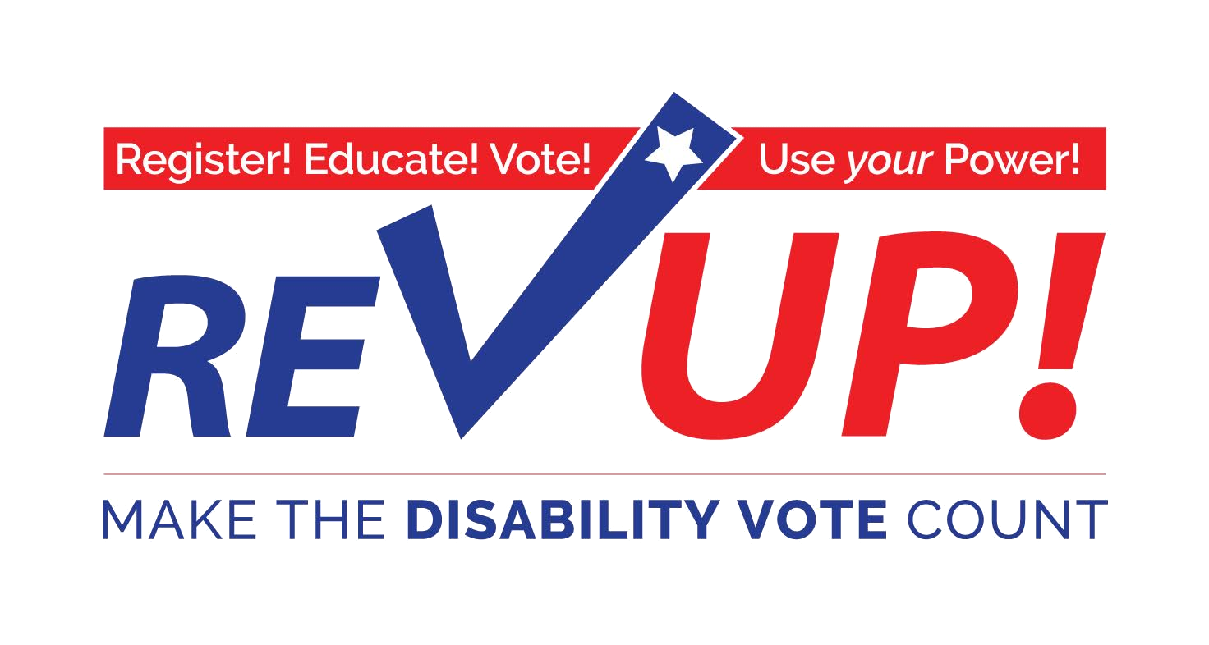

Candidate Forum Guide
Learn how to engage candidates on issues important to people with disabilities through hosting a candidate forum! This toolkit is prepared by the American Association of People with Disabilities’ (AAPD) REV UP Voting Campaign.

Table of Contents
Introduction 3
Chapter 1: Planning the Candidate Questions 5
Chapter 2: Centering the Disability Community 6
Chapter 3: Engaging with Other Candidate Forums 9
Additional Resources 10

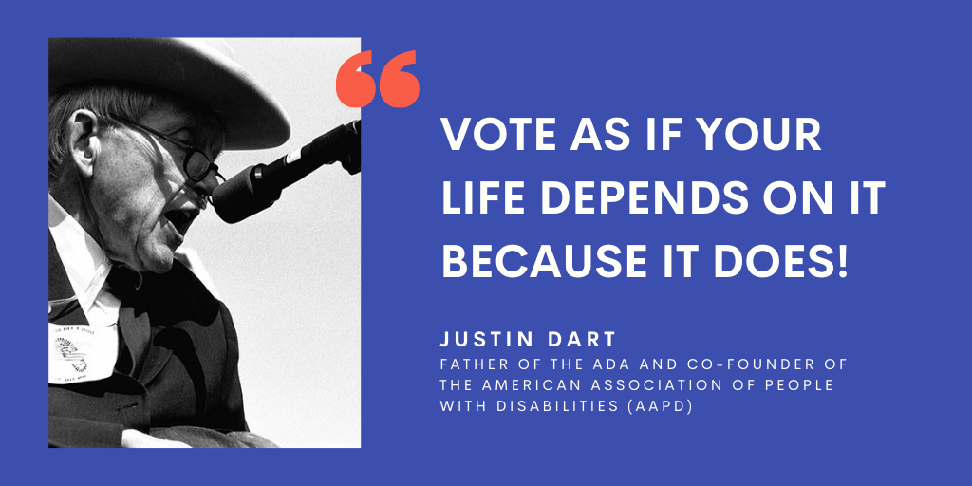

Introduction

What is the REV UP Campaign?

The REV UP Campaign, launched by the American Association of People with Disabilities (AAPD) in 2016, is a nonpartisan initiative that is composed of state and national coalitions that work to advance the Disability Vote. REV UP’s mission is to foster civic engagement and protect the voting rights of Americans with disabilities. REV UP stands for “Register! Educate! Vote! Use your Power!”

What is a candidate forum?
A candidate forum is a great tool to connect the disability community with candidates in an election while providing an opportunity to interact with them directly. Forums are a space where candidates can directly address issues that affect the disability community. They also educate the candidates and make them more aware of the issues that are important to the disability community. Additionally, if a candidate is elected, you can use their responses to the candidate survey to hold them accountable. This document serves as a guide for organizing and participating in candidate forums.
Candidate forums can involve anyone seeking elected office at any level of government - from federal to state office, from county to local offices. In fact, candidates for local offices may be more likely to attend a forum and, in some cases, may have the most direct influence on programs or policies that affect the local disability community.

Can 501(c)(3) Nonprofit Organizations Host and Participate in Candidate Forums?
Yes! While 501(c)(3) nonprofit organizations must remain nonpartisan, they can host or participate in candidate forums. There are two main requirements for nonprofits to follow:
- If hosting a forum, you must invite all candidates running in a particular election and you must conduct an equal amount of outreach to get candidates to respond. Whether or not a candidate responds and participates is their decision and will not affect your 501(c)(3) status.
- Summaries or recaps of candidate forums should include responses from the candidate(s) directly, without any edits, abbreviations, or commentary.
- Candidates must be given equal time to respond to questions.
You can learn more about nonprofits and political campaigns from the Internal Revenue Service (IRS) – watch a webinar or read the PDF course.

Questions for Candidates
The REV UP Campaign has developed a Candidate Survey, which includes a variety of questions addressing topics that are important to the disability community. You can use these questions or create your own. Think of this survey as a starting point!

Reporting Back to REV UP
If you plan a candidate forum or related event, let us know by emailing akemerling@aapd.com. We want to know how you are engaging candidates and your community in issues important with disabilities. We also want to be able to support and share your event!

Other Candidate Forum Guides

Nonprofit VOTE
Nonprofit VOTE provides tools and resources to expand the role of America's nonprofits in promoting active civic participation and democracy.
- Hosting A Candidate Forum
- Candidate Forum Checklist
- Voter Engagement Resources
League of Women Voters
The League of Women Voters of the United States encourages informed and active participation in government, works to increase understanding of major public policy issues, and influences public policy through education and advocacy.
- Candidate Forum Guidelines – League of Women Voters of Wisconsin
- FAQ's Candidate Forums-Debates – League of Women Voters
- A Toolkit for Candidate Events: How to Hold a Successful Candidate Event - League of Women Voters
American Association of University Women (AAUW)
The American Association of University Women (AAUW) is the nation’s leading voice promoting equity and education for women and girls.
- How to Organize a Candidate Forum

Chapter 1: Planning the Candidate Questions
The REV UP Issues Guide provides a comprehensive, concise overview of the issues and legislation that significantly impact the disability community. Use the Issues Guide as a reference to educate yourself, other voters, the media, and candidates. You can adapt this issue guide to reflect the priorities of your local community.
A candidate survey is a great tool to help the disability community learn more about candidates, and specifically how those candidates would address issues that impact people with disabilities. They also make candidates more aware and educated on the issues that are important to the disability community. The REV UP Campaign developed a Candidate Survey, which includes a variety of questions addressing topics that are important to the disability community.

Recommended Questions from the REV UP Voting Campaign
The REV UP Candidate Survey Template includes many sample questions to include in your candidate forum. Below are just a few sample questions to get you started thinking about what kinds of questions you can ask candidates you participate in a forum:
- What is your prior experience addressing disability issues, and how will you ensure that people with disabilities play an active role in your administration?
- Despite the protections provided by the Americans with Disabilities Act (ADA), the unemployment rate of people with disabilities continues to be much higher than that of people without disabilities. What efforts would you take to address this?
- If elected, how would you make sure that people with disabilities have access to long-term services and supports (LTSS) so that they can receive services and supports in their communities, rather than in segregated and isolating facilities?
- What would you do to expand access to affordable and accessible transportation for people with disabilities, especially in rural areas?
- What will you do to ensure people with disabilities have equal access to the fundamental right to vote?
- There is a shortage of accessible, safe, and low-income housing for people with disabilities. How would you propose to increase the inventory of housing throughout the state?
- How will you work to expand access to affordable, comprehensive health care coverage for people with disabilities?
- Over 30 years after the ADA, people with disabilities still contend with inaccessible infrastructure from transportation to storefronts, and more. What will you do to fight discrimination and enforce the ADA?

Chapter 2: Centering the Disability Community
The candidate forum guides on the previous page may already cover some of these topics, but the following recommendations should be considered for any disability organizations or advocates that want to organize their own, disability-specific candidate forum.

Establish a Broad Coalition of Partners
The REV UP Campaign encourages area disability organizations to work collaboratively on scheduling events. Many national, state, and local civic organizations that already work on voter registration may also be interested in partnering with disability organizations.

Potential partners include:
- State Protection and Advocacy agencies
- Local Centers for Independent Living
- Statewide Independent Living Councils
- State Developmental Disabilities Councils
- United Spinal Association
- National Association of the Deaf
- National Federation of the Blind
- American Council of the Blind
- Association of University Centers on Disabilities
- State and local chapters of The Arc
- State and local libraries
- State and local chapters of the League of Women Voters
- Local media and broadcasters
Check the list of REV UP events to see if events are already being organized in your area. You can also email akemerling@aapd.com for assistance connecting with other REV UP advocates in your state.

Questions and Information Focused on Disability
The REV UP Campaign has developed a Candidate Survey, which includes a variety of questions addressing topics that are important to the disability community. Use this document as a resource when developing questions for your forum. Sending candidates local information related to disability is another way to use forums to educate candidates.

Accessibility and Accommodations
It is important to consider accessibility and accommodations that attendees will need – wheelchair access, sign language interpreters, CART, materials available in alternate formats, and more – in order to participate fully in your candidate forum. accessibility and accommodations will vary between in-person and virtual events, and it is important to plan ahead to ensure that your event will be as accessible as possible. Additionally, make sure to provide a way for attendees to request any additional accommodations needed during the event.
The resources below outline accessibility considerations for both virtual and in-person events.
- A Planning Guide for Making Temporary Events Accessible to People With Disabilities – ADA National Network
- How to Make Your Virtual Meetings and Events Accessible to the Disability Community - Alaina Leary for Rooted In Rights
- Holding Inclusive Events: A Guide to Accessible Event Planning - Pacific Alliance on Disability Self Advocacy
- How to Make Your Social Justice Events Accessible to the Disability Community: A Checklist - s.e. smith for Rooted in Rights
- Digital Accessibility in the Age of COVID-19 - AAPD
- How to Make Your Virtual Meetings and Events Accessible to the Disability Community - Alaina Leary for Rooted In Rights
- GOTV + Organizing Accessibility - The Women’s March

Forums as Educational Opportunities for Candidates
A candidate forum can educate the candidates and make them more aware of the issues that are important to the disability community. Candidate forums represent an opportunity for the disability community to connect with candidates who may vote on or implement policies that affect us if they are elected. It is also important to remain credible, fair, and nonpartisan during these forums. Sending questions to candidates in advance of the forum may make them feel more comfortable and likely to participate in the event. Through candidate forums, you can present key issues important to people with disabilities in your communities and then hold candidates responsible for their positions and promises to the disability community.

Let us know about Your Candidate Forum!
The national REV UP Campaign wants to know about any candidate forums you plan in 2021 so we can promote your event and keep a record of voting activities. Email akemerling@aapd.com with your event plans and any questions you may have.

Chapter 3: Engaging with Other Forums
You do not have to organize your own candidate forum for candidates to answer disability-related questions. You can attend forums where audience members are invited to ask questions or contact organizers of those forums to ask them to include a disability-related question in their pre-selected list for candidates.

Where to Find other Forums
- Upcoming Debates and Forums – Vote411.org
- Town Hall Project
- Check for a list of candidate forums or events on your State or Local Election Office website

Tips for Initial Outreach as Forum Organizers
- Reach out to candidates as far in advance of the event as possible.
- Provide some statistics about the disability community in your state or city. You can check out the American Community Survey or the Disability Statistics Compendium for some disability data.
- Offer a handful of sample questions for the organizers to consider.
- If possible, conduct outreach jointly with other disability and community organizations that support incorporating disability-focused questions into the forum.

Additional Resources

REV UP Resources
- Voter Resources Center
- Upcoming Events
- Voting Statistics
- Logos and Graphics
- National Disability Voter Registration Week Toolkit
- Candidate Survey

Other Resources
- Voting and Elections – USA.gov - Official voting and elections website of the United States.
- U.S. Election Assistance Commission - The U.S. Election Assistance Commission is an independent agency of the United States government charged with developing guidance to meet the Help America Vote Act of 2002.
- Political Campaigns and Charities - Remaining Nonpartisan - The Internal Revenue Service (IRS) has a guide to help nonprofit organizations determine how to legally participate in voter education and engagement activities. Watch the webinar or read the PDF course.
- SignVote - SignVote is a Deaf and Hard of Hearing community-based GOTV mobilization effort. They have resources and instructional videos in American Sign Language.
- National Voter Registration Day (September 28, 2021) - National Voter Registration Day is a national holiday celebrating our democracy. It is a day of action across the country to encourage voter registration in advance of Election Day.
- Nonprofit VOTE - Nonprofit VOTE provides tools and resources to expand the role of America's nonprofits in promoting active civic participation and democracy.

About AAPD and REV UP
The REV UP Campaign, launched by the American Association of People with Disabilities (AAPD) in 2016, is a nonpartisan initiative that coordinates with national, state, and local disability organizations to increase the political power of the disability community while also engaging candidates and the media on disability issues. The Campaign focuses on voter registration, education, access, and engagement. REV UP stands for Register! Educate! Vote! Use your Power!
AAPD is a convener, connector, and catalyst for change, increasing the political and economic power of people with disabilities. As one of the leading national cross-disability civil rights organizations, AAPD advocates for the full recognition of rights for the over 61 million Americans with disabilities. To learn more about AAPD, visit www.aapd.com.

Questions?
Do you have questions about hosting a candidate forum or need additional resources? Let us know! Email Alexia Kemerling, the REV UP Voting Campaign Coordinator, at akemerling@aapd.com.

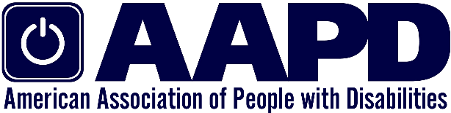

2013 H Street, NW | 5th Floor | Washington, DC 20006 | 202-521-4316 | www.aapd.com

